Large and Social Networks

Project 3 Report

Georgios Valavanis, AM: 2019030065

Georgios Andreadis AM: 2019030081

1. M/M/1 Queue Simulation:

At first we simulated an M/M/1 queue.

To find the theoretical E[T] (response times) for each lamda the below equation was used:

$$E\left[T\right]=E\left[N\right]∕λ=\frac{1}{μ-λ}$$

After simulating 15000 jobs the following plot occurred:

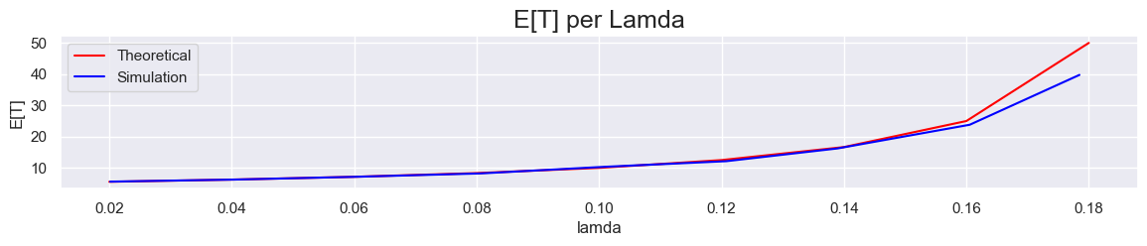

We can see that the simulation values are almost the same with the theoretical ones until the system becomes heavily loaded (lamda >= 0.16). Then the simulation values start to deviate from the theoretical ones, by a small margin.

1. M/G/1 FCFS Queue Simulation:

In order to find the theoretical E[T] for the M/G/1 system the below equation was used:

$$E\left[T\right]=E\left[s\right]+\frac{λE\left[s^{2}\right]}{2\left(1-ρ\right)}$$

Where:

$$E\left[s\right]=0.98*1+0.02*201$$

And:

$$E\left[s^{2}\right]=0.98*1^{2}+0.02*{201}^{2}$$

The simulation seems to converge for n = 50.000 jobs. After running it we get the following plot:

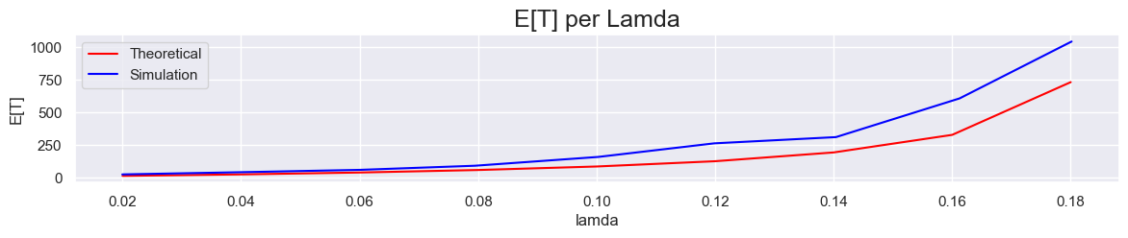

Simulation values seem to converge with the theoretical ones until lamda >= 0.1. Then they start to deviate from the theoretical ones, at first by a small margin and then, when the system is heavily loaded, by a bigger one.

This may happen because in theory there is exact 98% of a small job occurring and 2% of a large one occurring but in reality, there may be 97% of small jobs and 3% of bigger ones, congesting the system more than we expected.